Structure of Government of India
Ministers of IndiaThe Government in India or the central or the union government is divided into three main sections namely the executive, legislature and the judiciary shown as under. The responsibility of each section of the government is also mentioned along.
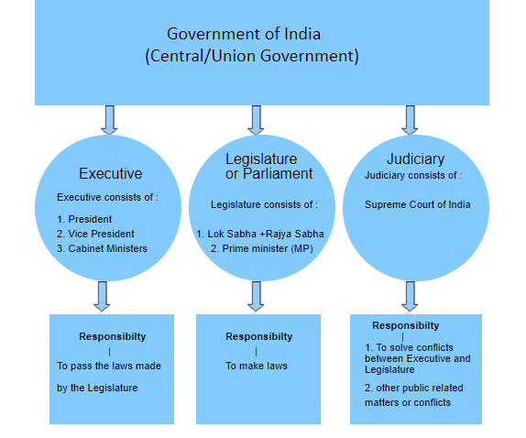

Structure of State Government of India
List of Chief Ministers of Indian StatesThe state legislature or the state assembly in India is headed by the chief minister of that state. The state legislature is divided into two parts namely the vidhan sabha and the vidhan parishad. The governor for the state assemblies is elected by the chief minister himself.
Below a complete flowchart is given about the state legislatures (assemblies) in India to make things more clear.

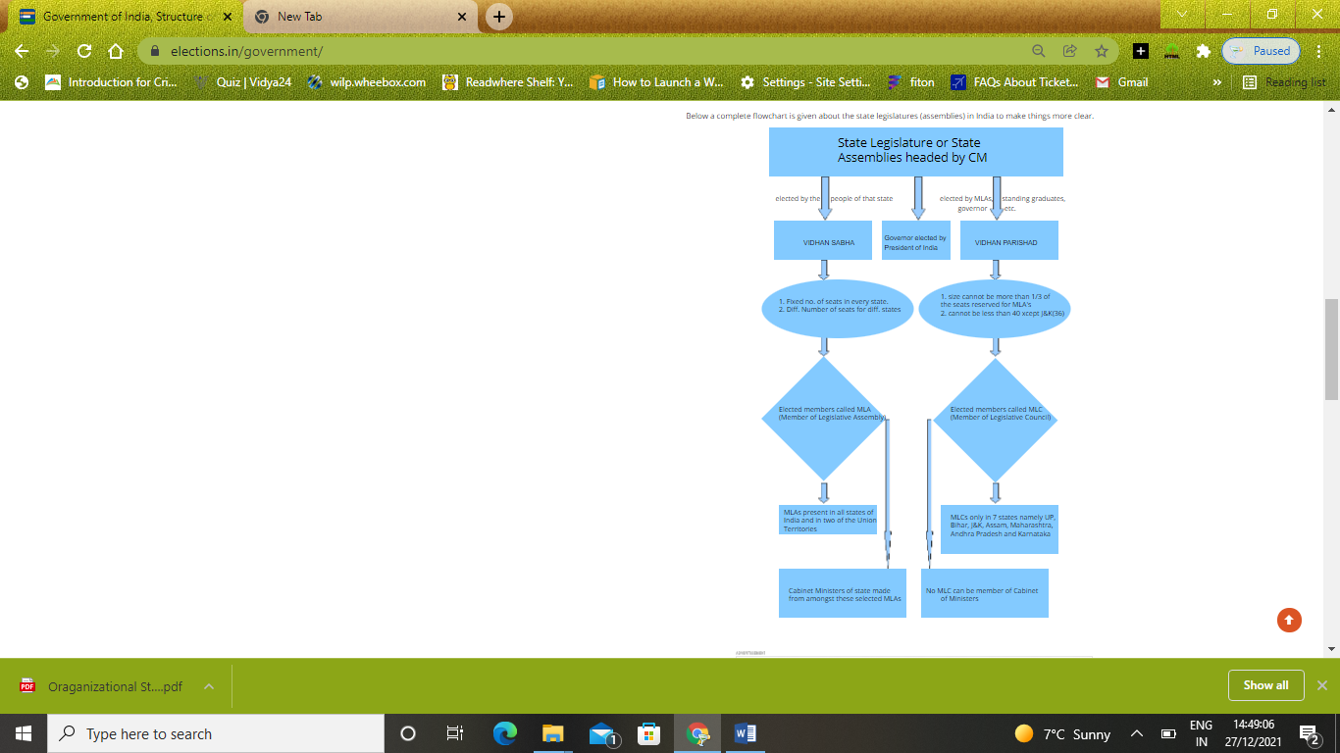

Structure of Union Territories Administration in India
List of State GovernorsThere are a total of 7 union territories in India namely Delhi, Pondicherry, Daman and Diu, Dadra & Nagar, Chandigarh, Lakshadweep and Andaman & Nicobar Islands. The administrative structure of Delhi, Pondicherry is quite different from those of the rest of the union territories.
Go through the flow chart to know the difference between the two sets of UT's in India.
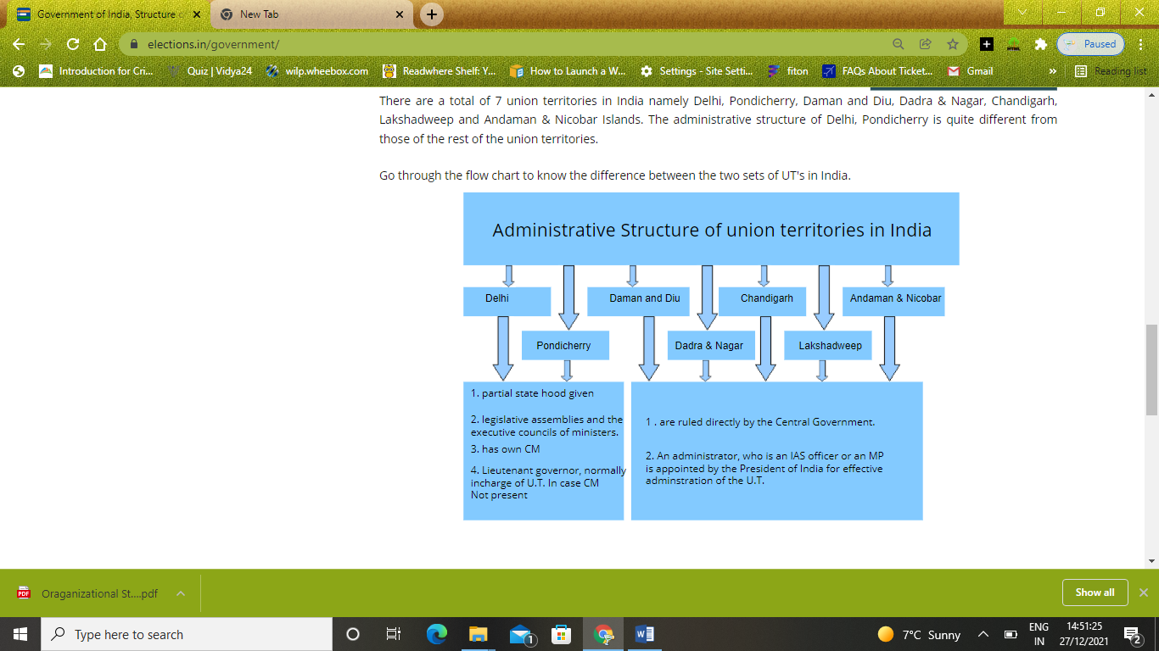

Structure of Local Government Bodies in India
Municipal Corporation in India

Village (rural) Administration:
Panchayati Raj: Basic unit of Administration in India, comprising of three levels -
1. Gram (Village) - Gram Panchayat (for one or more than one village)
2. Taluka/Tehsil (Block) - Panchayat Samiti
3. Zila (District) - Zila Panchayat

Gram Panchayat elects one Sarpanch and other members.
Powers and responsibilities of Gram Panchayat:
1. To help implementation of the development programmes and schemes of the Panchayat.
2. To identify beneficiaries for different programmes and schemes. However, if the Gram Sabha fails to identify such beneficiaries within a reasonable time, the Gram Panchayat shall identify the beneficiaries
3. To solicit support - in cash or kind or both and voluntary labour - from the public for community welfare programmes
4. To support the programmes of mass education and family welfare.
5. To promote unity and harmony among all sections of the society in the village.
6. To seek clarification from the Mukhiya, Up-Mukhiya and other members of the Gram Panchayat about any particular activity, scheme, income and expenditure.
7. To discuss and recommend appropriate action with regard to reports of the Vigilance Committee.
8. To consider levy of taxes, rates, rents & fees & enhancement of rates thereof.
9. To consider all such matters as may be referred by the Gram Panchayat for its decision.
Block Panchayat/Panchayat Samiti comprised of all Aarpanchas of the Panchayat samiti area, the MPs and MLAs of the area, the SDO of the subdivision and some other members from the weaker section of society. Block Panchayat/Panchayat Samiti works for the villages of the tehsil or taluka that together are called a Development Block.
Zila Panchayat Chief of administration is an IAS officer and other members are elected by the Gram Panchayats and Panchayat Samitis.

City (urban) Administration
Mahanagar Nigam (Municipal Corporation ): In Metro cities. At present around 88 Nagar Nigam are in operation. From every ward, there is a Sabhashad, elected by the voters, whereas one Mayor elected separately.
Nagar Palika (Municipality) : Cities having more than 1,00,000 population (there are exceptions as the earlier threshold was 20,000, so all those who have a Nagar Palika earlier, sustains it even though their population is below 1,00,000). From every ward, a member is elected whereas Chairman is elected separately.
Nagar Panchayat/Nagar Parishad (Notified Area Council/City Council): Population more than 11,000 but less than 25,000.
1. Water supply for domestic, industrial and commercial purposes.
2. Public health, sanitation conservancy and solid waste management.
3. Fire services.
4. Urban forestry, protection of the environment and promotion of ecological aspects.
5. Slum improvement and upgradation.
6. Urban poverty alleviation.
7. Provision of urban amenities and facilities such as parks, gardens, playgrounds.
8. Burials and burial grounds; cremations, cremation grounds and electric crematoriums.
9. Cattle pounds; prevention of cruelty to animals.
10.Vital statistics including registration of births and deaths.
11.Public amenities including street lighting, parking lots, bus stops and public conveniences.
12.Regulation of slaughter houses and tanneries.

